Hidden Creek Country Club—Member/Member Tournament
September 22nd-24th 2016
Cost: $ 125.00
Register: In the Pro Shop.
Time: 1:30 PM Shotgun Thursday and 8:15 AM Friday and Saturday
Format: Teams will be assigned to flights of six. Flights will be formed based on each team’s average handicap. Each team will play 45-holes (Five nine-hole matches) of two-man net best ball match play. Teams will play each other head to head within your flight. Flight winners advance to a shoot out to determine the overall winner.
Entry Fees and Your MGA Dues Include
- Carts Friday &Saturday.
- Assorted breakfast sandwiches on Friday &Saturday.
- Heavy Hors d’oeuvres Thursday night.
- Kegs all three days.
- Champions dinner for participants and guests (casual attire) immediately following the completion of the shootout on Saturday.
- Snacks and non-alcoholic drinks provided throughout the golf course during all matches. All mixed drinks and wine will be member ticket.
- Lunch Friday and Sat with assorted snacks during breaks.
Thursday
1:30 PM Optional Practice Round: Shot Gun Start
6:30 PM Stag Night/Rules Review and “Supplemental Event”
Friday
8:00—8:45 Check-In & Breakfast Sandwiches
9:00 Match #1 Shotgun Start
11:15-11:55 Snacks on the Hill
12:00 Match #2 Begins (Go to Next Match)
2:15—2:40 BBQ Lunch @ the Scoreboard
2:45 Match #3 Shotgun Start
5:00—?? Putting, Chipping and Other Skills Contests
Saturday
8:00—8:45 Breakfast
9:00 Match #4 Shotgun Start
11:30-12:10 Early lunch at the Scoreboard
12:15 Match #5 Shotgun Start
2:30 Break, Snacks &Refreshments at the Scoreboard
3:00 Shootout for Overall Champion Begins on #15
6:00 Champions Party PROPMTLY FOLLOWING the SHOOTOUT(Bring a guest)– Casual Attire
General rules and information
- The format will be a 45-hole, two-man net best ball, match play event.
- Players will be assigned to flights of six, two-man teams, based on each team’s average handicap.
- Each team will play all five nine hole matches against every team in the flight.
- Prizes will be awarded to the first place team in each flight, as well as to the top three teams of the shootout, the winner of which will be deemed the Overall Champion.
Tournament Rules & Scoring
- Each 9-hole match is worth 10 points. (1 point for each of the 9 holes plus 1 point to the team that wins the most points - in the event of a tie all points will be split)
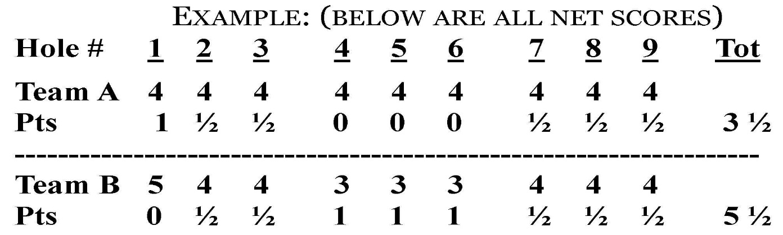
- Team B wins the match by a score of 5 ½ to 3 ½.
- Team B gets an additional point for winning the overall nine-hole match.
- Final Score of the match is Team B = 6 1/2 points Team A = 3 1/2 points.
- There is no limit as to how many points a team may win in any given match.
Handicaps
- Players receive 100% of his USGA handicap as of September 15, 2016.
- The maximum allowable handicap is 36.
- Each match will be stroked off the low ball with the strokes being awarded as they fall on the card, ½ shots are in effect.
- The Tournament Committee reserves the right to adjust a handicap.
Ties
- Ties for the flight champion will be determined as follows:
  - Will be resolved in favor of the team that won the most points in their head to head match, but both teams still advance to the Shootout.
  - If the teams in question tied their match the flight champion will be determined by highest total points scored against the 3rd place team.
  - If still tied then their total points against the 4th place team and so on.
  - Any tie unable to be resolved in this manner will be resolved by coin toss.
Shootout Rules
- The Shootout starts on Hole #15.
- Teams eligible for the shootout are as follows:
  - Winners of each flight (& ties).
  - Death Flight Winner – last place team and ties in each flight on Day 1 will enter the death flight (Death Flight Winner will be the total accumulated points for the last three nine-hole matches).
  - 4 Wildcards (& ties) - four highest point totals of non flight winners.
- Alternate shot (net stroke play) with the teams receiving strokes as they fall on the scorecard.
- Strokes will be calculated by the combined total of each player’s handicap divided by two (no half strokes).
- Natural pars ADVANCE throughout the Shootout.
- At least nine teams will advance to the 16th hole with any ties broken by a chip off on the 15th green; chip off - chip on green closest to hole.
- A maximum of three teams may be eliminated on each of the 16th and 17th holes. All ties will be broken by a chip off on each hole - chip on green closest to hole.
- Remaining teams left on the 18th hole playing for the overall championship. Any ties on 18thwill continue on to the 1st hole and so on until there is one overall winner.
- Low net score on 18th or succeeding hole wins. Ties for 2nd & 3rd place will share prizes.
*If the Shootout is rained out, the team that has accumulated the most points in the round-robin competition will be considered the Overall Member-Member Champion. If a tie exists in this case, we will have a chip-off on #18 green. In the event the shootout cannot be completed due to darkness, the overall winner of the teams remaining will be drawn by lot.

